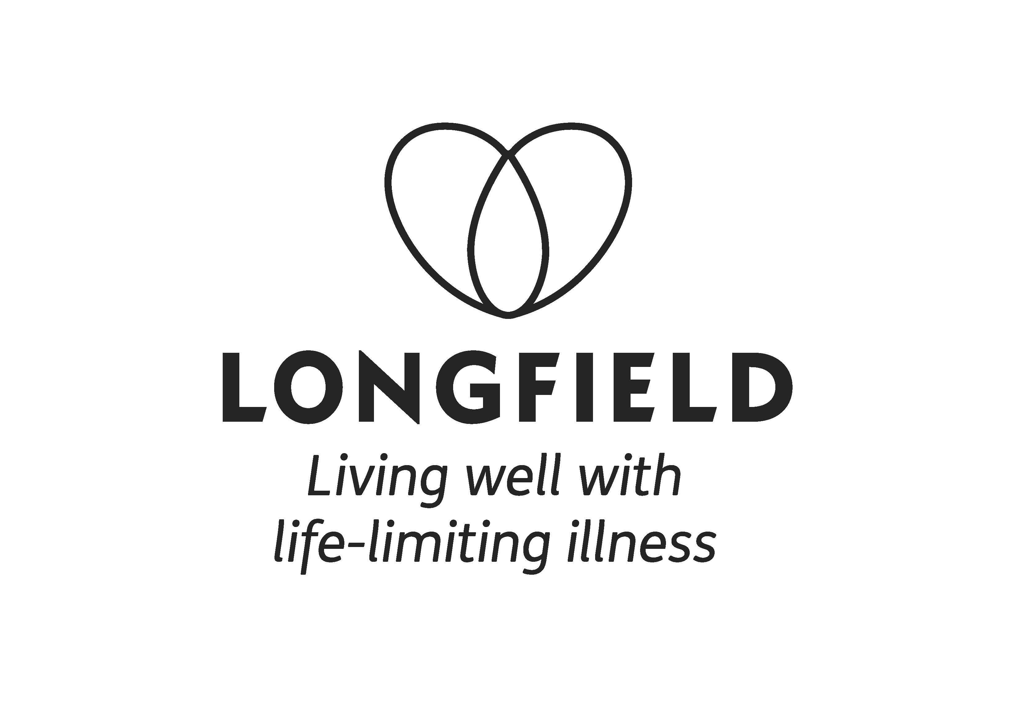
Complementary Therapy Volunteer Role Profile

Title: | Complementary Therapy Volunteer
Department: | Wellbeing
Reports to: | Complementary Therapist
Responsible to: | Wellbeing Manager
Aim of role: | To provide complementary therapy treatments as part of Longfield’s Wellbeing service, to provide complementary therapy treatments on a 1:1 outpatient basis to:  - patients living with a life limiting illness  - carers & family members  - people who have been bereaved  To work as a member of Longfield’s clinical care services team, completing necessary records and documentation.  To follow the direction of the Longfield complementary therapy team and the Wellbeing Manager.  Therapies currently offered are:  Massage, Aromatherapy Massage, Reflexology and Reiki.  All our treatments are adapted to be client centered and predominantly gentle and light touch. The duration of each treatment will depend entirely on the needs of the client and can range from 10 minutes to 45 minutes.
Time commitment: | Wellbeing Outpatients – minimum of one morning or afternoon a fortnight For 2 treatments (per volunteering session)  - between 9.00 – 3:00 pm, Monday - Friday  Plus attendance/completion of induction training regarding comprehensive adaptations for working with people with life-limiting illnesses including cancer, and mandatory training requirements. Some of the training will be online, and others may take place face to face within usual working hours (i.e. 9.00 – 5.00). Additionally, you will be invited to attend three complementary therapy volunteer team meetings per annum.

Tasks and Activities
- To provide complementary therapy sessions to patients and/or carers registered with Longfield.
- To complete necessary records and documentation in line with Longfield’s policies & procedures, and raise concerns or relevant feedback to service leads where appropriate
- To prepare and/or maintain resources and equipment used in the role

Qualifications, Experience & Skills

Essential:
- Professionally qualified Complementary Therapist; able to demonstrate qualification and competency meets minimum occupational standards relating to the therapy being practiced
- Hands on experience of providing health and wellbeing related complementary therapy
- Ability to work independently and as part of a multi-professional team
- Ability to work in a flexible, mature, compassionate and confidential manner
- Good time management
- Good listening skills
- Commitment to following policies and guidelines drawn up by Longfield

Desirable:
- Substantial experience of appropriate therapy
- Membership (past or current) of appropriate professional body

Personal Qualities & Attributes
- Flexible and adaptable approach to working with a diverse range of clients
- Emotional resilience and ability to maintain a healthy perspective
- Emotionally and physically comfortable working with patients with life-limiting illness
- Willingness to work in an adapted environment with very client centered treatments
- Willingness to reflect on one’s professional practice and learn from this
- Willingness to ask for feedback and take advice from colleagues
- Willing and able to make regular commitment to volunteering for Longfield

Dress code
- Clothing must fit properly and allow any activity undertaken by the individual to be done without compromising the dignity of the individual or the patient.
- Clothing that distracts other people is unacceptable, including T-shirts with offensive slogans, political symbols, graphics or imprints, and tight clothing. Dress must be wholly appropriate to perform his/her role responsibly.
- Footwear must be clean and neat with non-slip soles, have a low heel and soft base. Footwear must cover the whole of the foot (no open toed or open heeled shoes).
- A volunteer badge must be worn.
- Fingernails must be kept short and clean. Nail polish must not be worn
- False nails or nail extensions must not be worn.
- Jewellery is restricted to 1 pair of plain studs in the earlobes only and 1 plain ring/band on one hand only.
- No wristwatches.
- Perfume/Aftershave must be unobtrusive in nature.

Selection process
- If you are interested in the role you will be required to complete an application form and provide two references
- Applicants will be invited in for an informal meeting to discuss the role
- Longfield will apply for a DBS for you at our expense. Alternatively, if you have your own DBS for this role that has been issued within the previous 12 months, we can accept that

Continuing Professional Development
The following can be included for your Continued Professional Development:

- Volunteer Therapist Meetings
- Annual observed practice
- Skills development and advice
- A skills refresher can be provided

Mandatory training
You will be required to undertake a range of mandatory training, or if applicable demonstrate you are up to date with relevant mandatory training. Longfield’s mandatory training includes:

• Introduction to Longfield
- Moving & Handling Practical Training
- Working safely (H&S)
- Equality and Diversity
- Information governance
- Safeguarding

Mandatory training is delivered in a range of formats including face-to-face training and e-learning.

