Longfield Wellbeing Services Referral Form 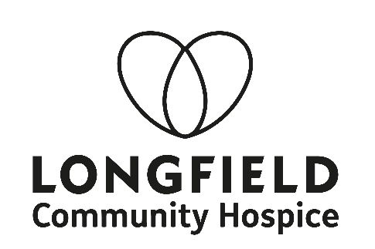

Burleigh Lane, Minchinhampton, GL5 2PQ

Tel: 01453 733706 or email longfield.8jg76@nhs.net
Referral forms are available to download from the Longfield website: www.longfield.org.uk

Date: | NHS No: | Referral taken by: (please print)
Surname: Gender: |  | Does Client consent to referral? Yes o No o  Consent to the sharing of data recorded at Longfield with any organisations that may care for the patient? (i.e NHS) Yes o No o  Consent to Longfield viewing data recorded at any other organisations that may care for the patient?  (i.e NHS) Yes o No o  Consent to be added to the mailing list to receive future Longfield Information? Yes o No o  Are you a: (please tick)  Patient o  Carer/ Family member o  Bereaved o
First Name:
Preferred Name: DOB:
Address:

Postcode:
Tel:
Mobile:
Can we leave a message?
Will you accept withheld numbers?
Email address:
How did you hear about Longfield?

Is GP aware of referral Yes ¨ No ¨  GP Name:  Surgery: |  | Name of referrer (please print)  Job Title:  GP/Surgery or Hospital:  Contact No:
Client Next of Kin/ Emergency Contact  Name:  Address:  Postcode: Tel:  Relationship: |  | Primary Diagnosis:
 |  | Medical & Psychiatric History/ Treatments.
What are you interested in accessing at Longfield Wellbeing Centre? If you are not sure, please tick triage (Please tick)

Services available for Patients | Services available for Carers | Services available for the Bereaved
Being In Nature | Being In Nature | Bereavement Friendship Cafe
Complementary Therapies | Carer’s café | Bereavement Support Group
Cooking for inspiration | Complementary Therapies | Bereavement Counselling
Counselling | Cooking for inspiration | Cooking for inspiration
Creative Space | Counselling | Fork & Talk
Creative Writing | Creative Space | Ladies Group
Introduction to Nordic Walking | Creative Writing | Men’s Group
Ladies Group | Family & Carers Support | My grief journey through art
Living well with Fatigue & Breathlessness Group | Fork & Talk | Stronger Together
Men’s Group | Introduction to Nordic Walking | Walk & Talk
Mindsong | Ladies Group | Young Person's Group 18 - 50  (in development)
Move More Programme | Living well with Fatigue & Breathlessness Group
Your life, Your death | Men’s Group
Physiotherapy | Mindsong
Relaxation Programme | Your life, Your death
Tai Chi Movements for wellbeing | Relaxation Programme
Young Person's Group 18 - 50 (in development) | Tai Chi Movements for wellbeing
Young Person's Group 18 - 50
(in development)
Triage | Triage | Triage

Are you able to transport yourself to Longfield? Yes ¨ No ¨
Mobility (Include any walking aids):

Volunteer transport information: (check any walking aids, any issues with parking, getting in and out of a normal car)

Any allergies or intolerances:
Any concerns of the client or family / carers, or other information relevant to this referral:

